DUO-Korea Fellowship Programme

1. General Description
CAUTION: If any application falls under the following 3 cases, the application is disqualified and will not be considered for selection. If such case is found after the selection, the Secretariat may still reserves the right to cancel the fellowship (BOTH Korean/European students) and request the return of the fellowship in full to the Secretariat. Therefore, the contact persons of the institutions should carefully confirm that the applications do not fall under the following 3 cases.
- Case 1. In case of the Transfer of Credits, the credits for transfer are less than 10 credits (20 ECTS): language and sport courses are NOT to be counted
- Case 2. GPA/ECTS written on the application are different from those of the transcript
- Case 3. During the application period (2019 spring term), the Korean student does not stay in Korea (leave of absence is allowed) or the European student does not stay in Europe (leave of absence is allowed)

DUO-Korea Fellowship Programme was established in 2001 with the aim of promoting exchanges of people between Korea and 30 European countries on a balanced and permanent basis. In this respect, DUO-Korea requires that a PAIR (two persons) of students be exchanged in the framework of a cooperative project. Definitions of students are as below:
- Students: undergraduate(bachelor) and graduate(master) students who are currently enrolled in universities
[30 European member countries]
Austria, Belgium, Bulgaria, Croatia, Czech Republic, Cyprus, Denmark, Estonia, Finland, France, Germany, Greece, Hungary, Ireland, Italy, Latvia, Lithuania, Luxembourg, Malta, Netherlands, Norway, Poland, Portugal, Romania, Slovakia, Slovenia, Spain, Sweden, Switzerland, the U.K.
N.B.: All applicants shall maintain their “student status” at the time of application until the time they are engaged in exchange projects. Graduate students must check “Graduate” under numbers on page 1.
※ If the student has already started the exchange before the application period is not acceptable.

1.1. Eligibility
Due to this unique nature of this programme, in order to be eligible, the following are required:

Your exchange project fulfills all four requirements below:
- An educational institution in Korea(home institution) and an educational institution in Europe(host institution) have established an academic cooperative agreement;
- The Korean home institution has selected a Korean national student enrolled at the home institution to send to the European host institution, and such selection has been accepted by the European host institution;
- The same European host institution has selected an EU citizen student enrolled at the host institution to send to the Korean home institution, and such selection has been accepted by the same Korean home institution.
- If the Korean student has already started the exchange or the European student has already started the exchange in Korea before the application period for DUO-Korea 2019, are not acceptable.

1.2. Duration and Funding
DUO-Korea 2019 is for exchange projects, which will start from August 2019 and end before September 2020 to avoid duplication of implementation period of exchange projects selected by DUO-Korea in the ensuing years.

The selection of DUO-Korea 2019 is made ONLY once a year. In this respect, those who are planning to exchange in Spring Semester of 2020(January-August 2020) shall apply for DUO-Korea 2019.

The duration and the amount of the fellowships are standardized as follows:
- For students: 1 semester (or four months) for an amount of 8,000 Euro for both students in a pair (4,000 Euro each).
- Maximum duration for application is 1 semester (4 months).
The duration of exchange should be at least one semester. Exchange of less than one semester is NOT allowed. If a semester is longer than 4 months in the visiting institution, fellowship will be given for 4 months. If a semester is less than 4 months in the Home/Host institutions, then the scholarship will be adjusted on a pro-rata basis.

2. Application Procedure

2.1 Application Period
Applications will be accepted from April 1(Mon) to May 10(Fri), 2019 local Korean time. Applications sent or posted after May 10 will not be accepted.

2.2. Who Applies?
The educational institution in Korea applies on behalf of both institutions and people who are to participate in the exchange. European institutions in partnership with Korean institutions shall cooperate fully with Korean institutions in supplying precise information of European applicants. Individuals wishing to take part in exchanges are advised to contact the relevant offices ONLY (e.g. International Relations Offices) of the educational institution to file an application for this program.
Professors or lecturers cannot be the contact person of Home Institution for DUO-Korea 2019. ONLY a staff of International Relations Offices or other similar department in university can be the contact person.

2.3. Documents
- Filling out an Online Application Form ONLY.
- A copy of Cooperation Agreement (or Memorandum of Understanding for cooperation) between paired institutions OR declaration of intention to set up new cooperation agreement by uploading to the website with scanned files (ONLY valid one).
- A copy of Passport of paired applicants (a copy of national registration card for Koreans or citizen card for Europeans are acceptable), by uploading to the application system with scanned files.
- A copy of Transcript of paired applicants by uploading to the website with scanned files (including the grades until fall semester 2018)
- A Motivation Letter of paired applicants by uploading to the website (the form is on our website www.asemduo.org).
If courses listed on the application differ from the actual courses, Contact Persons or Persons of Exchange are responsible to inform the Secretariat for approval; if this procedure is not taken beforehand, fellowship award to both students is subject to cancellation and consequently refund

2.4. Application Submission
- Click JOIN US button and find the Name of Home Institution to get an ID.
※ If you don’t find the name of your institution, please contact the secretariat to add your institution to the list.
- Enter your password with the minimum information of the contact person in Home University. One institution can ONLY get one ID.
- There should be ONLY one contact person in the same Home Institution.
- Home Institution should fill out the whole application including the information of Host Institution. Application Form in PDF format can be downloaded from the ASEM-DUO website (http://www.asemduo.org) at the banner of Forms.
- Once completed, please make it sure to submit your application by clicking “submit” button. Home Institution should get a confirmation email from the secretariat within 3 days after completion of submission. If you don’t get a confirmation email, please contact admin2@asemduo.org promptly.
- The rest of the documents (Cooperation Agreement, Passport Copies, Transcripts and Motivation Letter) can be uploaded in the last step of the application process.

2.5. Selection Method
A Korean Selection Committee, comprising Korean experts and representatives from European countries, will make the selection after the application deadline. The decision will be announced by June 2019.
The notification will be displayed on website, www.asemduo.org and the Secretariat will directly notify Contact Persons/Awardees in writing. Hard copies of notification and Letter of Acceptance (forms are also available at www.asemduo.org) will be forwarded to both home and host institutions. Contact Persons may download forms of Letter of Acceptance, if they so wish.
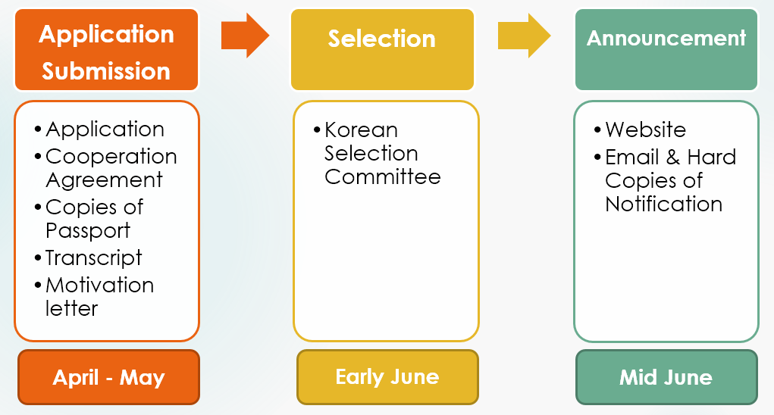

2.6. Selection Criteria
New project based application under DUO-Korea shall be given priority in selection. Besides, the following is the selection criteria according to status of applicants;
- Motivation letter
- Courses to take in host institution
- Recommendation of school
- GPA

2.7. Fellowship Grants
The DUO-Korea Fellowship for the selected exchange projects will be paid directly by the Secretariat to the bank accounts of students who participate in those exchange projects. There are no restrictions in using the fellowship. It can finance the tuition, and living or travel expenses. However, if you stay in host country less than 4 months (120 days) or traveled without informing the secretariat in advance, the fellowship will be adjusted on a pro-rata basis.

3. Instruction for Application Form

3.1. Language of Application
You should write your application in English.

3.2. Structure of the Application Form
- Page 1. – Home Institution
The first box of ID number and Date of submission is for the use of the secretariat only. Please, start from filling out information of Home Institution.
  - CONTACT PERSON means a regular staff of Korean university who arranges the exchange project and is willing to communicate with the Secretariat in such events as verifying application details, transferring fellowship, monitoring exchanges and providing further information on the status of the exchange. ONLY a staff of International Relations Offices or other similar department in university can be the contact person.
  - PERSON OF EXCHANGE shall be any Korean student who will participate in the exchange.
  - In a box for Institutional Criteria for selecting person to be exchanged, describe why you (or your school) recommend the person of exchange for fellowship in detail.

N.B.: For each pair of an exchange project, the exchange period of Korean and European students need not necessarily coincide, and the field of exchange need not be the same.

- Page 2. – Host Institution
In this page, provide information of host institution involved in the exchange project. The host institution shall be resided in 30 European countries.
  - CONTACT PERSON means a regular staff of European university who arranges the exchange project and is willing to communicate with the Secretariat in such events as verifying application details, transferring fellowship, monitoring exchange and providing further information on the status of the exchange.
  - PERSON OF EXCHANGE shall be any European student who will participate in the exchange.
  - In a box for Institutional Criteria for selecting person to be exchanged, describe why you (or your school) recommend the person of exchange for fellowship in detail.
  - Confirmation on Agreement with Host Institution (TO BE SIGNED BY CONTACT PERSON at the Korean Home Institution): since the contact person in Korean university is required to complete the application on be half of two people who will participate in the exchange and the host institution (European school), he/she should confirm here by checking on “YES” that the contact person in the host institution also agree with this submission of the application.

- Page 3. – Description of Exchange Program
In this section, please describe the type, duration and purpose of exchange as instructed on the form.
  - Type of exchange: please check appropriate boxes to specify whether students for exchange are in undergraduate or in graduate study.
  - Duration of Exchange: As stipulated on the DUO-Korea General Description, duration of DUO-Korea Fellowship is standardized on a semester basis. For students, 1 semester means 4 months.
  - Purpose of Exchange: Please, specify what the purpose of the exchange is.

- Page 4. – Exchange Details/ Source of Finance
Under this heading, Korean and European students’ class schedules should be listed during their exchanges periods. Details shall be elaborated as they will determine selection of application.
CAUTION: If the courses listed on the application differ from the actual courses, Contact Persons or Persons of Exchange are responsible to inform the Secretariat for approval; if this procedure is not taken beforehand, fellowship award to both students is subject to cancellation and consequently refund. Also intensive language courses and the sport courses by students is not honored in this program
If this exchange project has any other source of finance, please specify.

- Page 5. –Certification of Authenticity
After completing all relevant items in appropriate manner on the entire field of application, please write the date and the names of contact person of home institution and the president or Director of institution in the section of Certification of Authenticity. Submit the form to the Secretariat by clicking “submit” button. The original printed version with the signatures will be requested if your project has been selected.

A Copy of Cooperation Agreement, Passport Copies, Transcripts, Motivation Letter of paired applicants should be attached. The preferred file formats of Cooperation Agreement and Passport for attachments are JPG. or PDF.
※Save the attachment files as a Surname_Given name order (e.g. John_Smith).

3.3. After the Submission: Acknowledgement
The acknowledgement on the receipt of submission will be sent to the contact person in Korean home institution by e-mail within 3 working days after submission. If there is any application with incomplete or improper information, further information will be individually requested by the Secretariat.

If the application is necessary to be revised, secretariat will individually send the contact person an email with comments. Please submit your revised application through the online system again within 48 hours. If we do not receive the revised one within 48 hours, we regard it as a notice of abandonment.

