1. 보조기구 아이디어 공모전

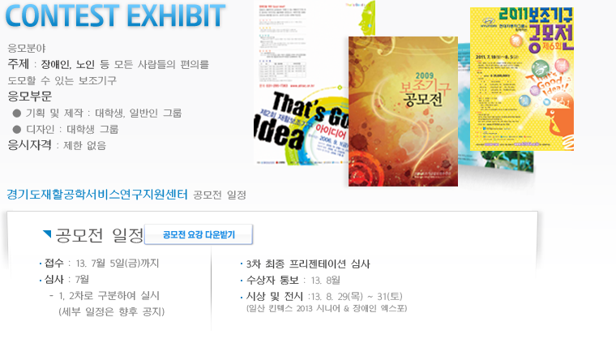



<http://www.atidea.or.kr/bbs/board.php?bo_table=m21>

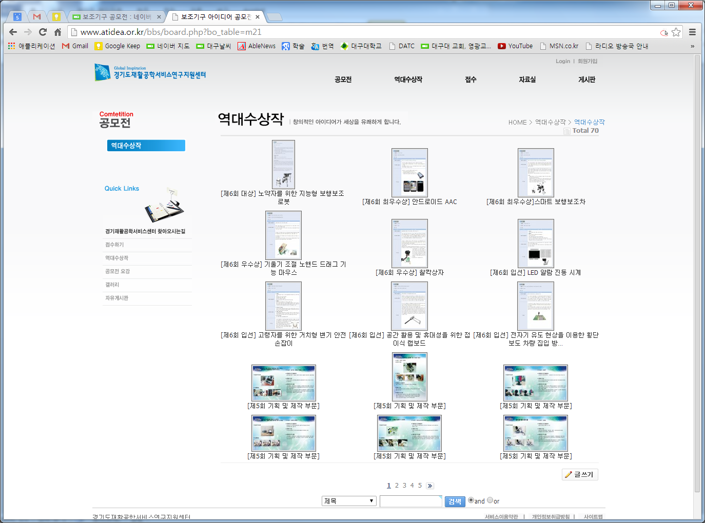

1. i-CREATe student Design Challenge

<http://atrac.or.kr/> 사진으로 다시 보는 [2013 국제 보조공학 심포지엄]



**1. 보조기구 공모전 수상작 전시**

  - 일시 : 8. 29(목) ~ 8. 31(토), 3일간 전시

  - 장소 : KINTEX 제 1전시장 3,4홀 內 독립 행사장

  - 주최 : 경기도재활공학서비스연구지원센터

  - 주요내용 : 공모전 수상작 부스 운영

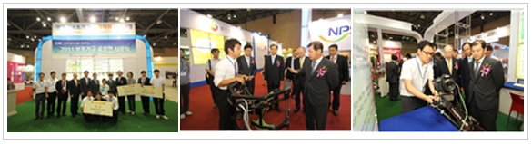

**사진으로 다시 보는 [2013 국제 보조공학 심포지엄]**

05.jpg

공모전 전시 부스는 제7회 보조기구 아이디어 공모전에서 수상한 작품들을 전시하고, 우리 직원들을 배치해 작품에대한 설명도 친절하게 해드렸습니다. 특히, 대학생들이 많은 관심을 보이며 공모전이 또 언제 하는지 물어보고 가는 경우도 있었답니다.

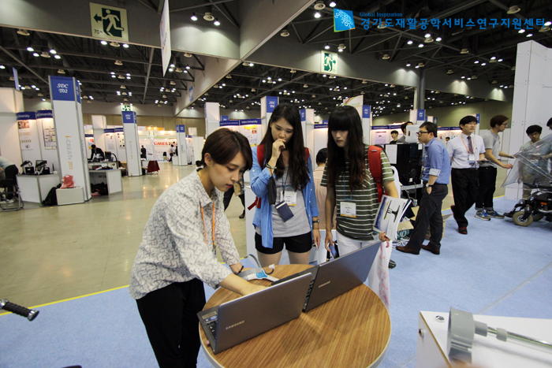

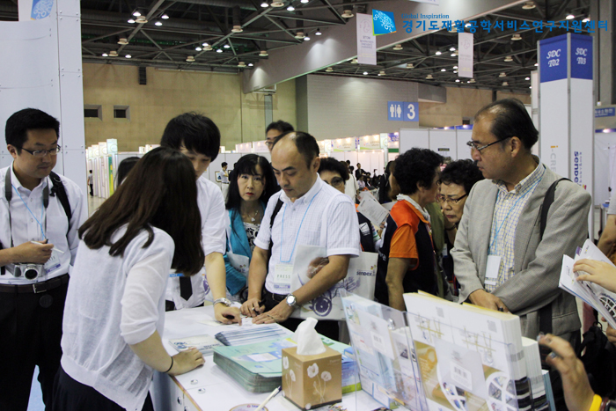

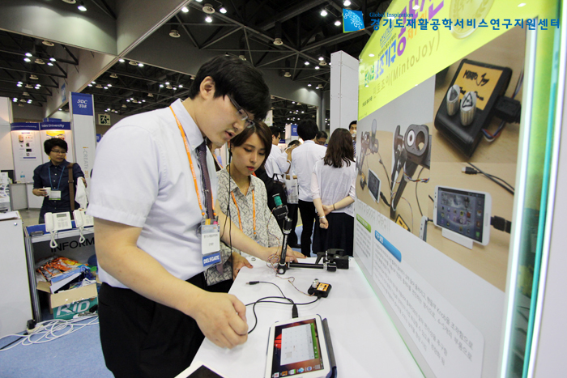

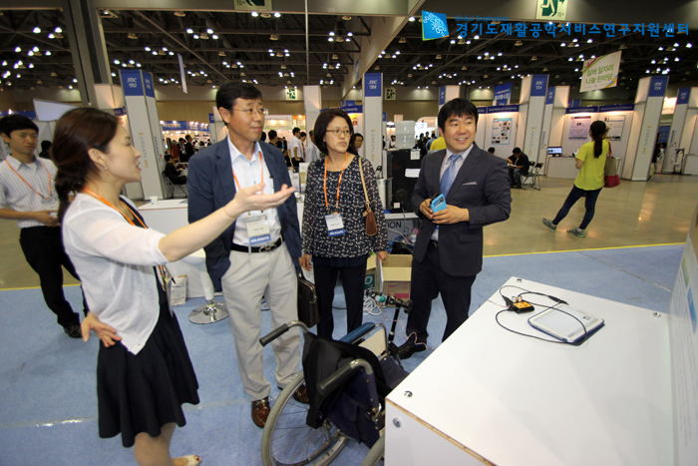

6th. SDC

<http://www.icreateasia.org/images/stories/icreate2013/ProgramBookv19%20(AWT).pdf>

(p60)

6th SDC winner

<http://www.icreateasia.org/images/stories/icreate2013/SDC%202013%20Winners.pdf>

<https://7thicreate2013.shutterfly.com/activityfeed/7>

7th i-CREATe 2013 in… (사진 앨범)

# [**7th Student Design Challenge(2014)**](http://www.icreateasia.org/index.php?option=com_content&view=article&id=162:sdc-2013&catid=47:general-2014&Itemid=207)

<http://www.icreateasia.org/index.php?option=com_content&view=article&id=162&Itemid=207>

### Submission is now open! Closing date for submission is 5th May 2014

**Please submit your Entry form via email to*[sdc[at]icreateasia.org](mailto:sdc@icreateasia.org)*  
Click here to http://www.icreateasia.org/images/M_images/dl.png**[**download**](http://www.icreateasia.org/images/stories/icreate2014/SDCentryform2014.doc)**Entry Form**

**What is the Student Design Challenge (SDC)?**

The Student Design Challenge encourages students to find creative and innovative solutions to improve the quality of living of elderly and people with disability. There are 2 category in this challenge.

**Design Category**

Student Students entries are expected to apply User-Centric Design process to develop solutions for assistive or rehabilitation applications. The proposed solutions need not have technological components but must be technically feasible. An illustration, in the form of drawing, 3D model, video, animation or functional prototype, is mandatory to illustrate the proposed.

**Technology Category**

Students entries are expected to apply principles in engineering and information technology to design and implement Assistive & Rehabilitative Technology solutions to address the issues / problems faced by the needy, their caregivers and clinicians. A functional prototype is mandatory to demonstrate the proposed solution.

**Judging Guidelines for Technology Category**

Creativity / Idea Novelty (20%)

Impact on Society and/or Professional Practice (20%)

Commercialization Potential (20%)

Prototype Engineering (20%)

Usability / Ergonomics (20%)

click [here](http://www.icreateasia.org/images/stories/icreate2014/SDC2014%20Judging%20Guidelines-Technology%20Category.pdf) for details

**Judging Guidelines for Design Category**

Creativity / Idea Novelty (20%)

Impact on Society and/or Professional Practice (20%)

Commercialization Potential (20%)

Prototype Design and Implementation (20%)

Usability / Ergonomics (20%)

click [here](http://www.icreateasia.org/images/stories/icreate2014/SDC2014%20Judging%20Guidelines-Design%20Category..pdf) for details

**Competition Requirements**

This challenge is open to post-secondary education, undergraduates and postgraduates. These include Universities, Polytechnics and Institutes of Technical Education students. Submissions are invited from all students at all stages of their academic studies.

There is no limit to the number of teams that may compete from any given academic institute and each team is allowed to have up to 4 members.

Entries submitted should not exceed two years of development. All participants must provide proof that they are students at the time of work for the challenge was conducted.

Successful teams must bring their prototypes for the presentation. Large prototypes that are not transportable will be taken into consideration during the judging.

Selected entries will be notified by emails and are required to register for i-CREATe.

**Competition Guidelines**

1. Individual / teams will submit the Entry form to [sdc[at]icreateasia.org](mailto:sdc@icreateasia.org). Expert reviewers will evaluate submissions to be selected to attend the final Student Design Challenge at i-CREATe convention
2. Selected teams will be expected to attend the convention with an A1 size poster outlining their design and innovation. Prototypes will have to be displayed together with the posters at the convention to a panel of Student Design Challenge Judges.
3. The finalists will be given 5 to 10 minutes oral presentation on their design to the panel of the Student Design Challenge Judges and i-CREATe convention attendees.
4. Based on the judging criteria, the judges will rank and identify overall winners of the competition.

**Awards**

|  |  |  |
| --- | --- | --- |
|  | **Design** | **Technology** |
| **Champion** | USD 1400.00 and certificate for all members | USD 1400.00 and certificate for all members |
| **1st Runner-up** | USD 700.00 and certificate for all members | USD 700.00 and certificate for all members |
| **2nd Runner-up** | USD 350.00 and certificate for all members | USD 350.00 and certificate for all members |
| **Merit award** | Certificate for all members | Certificate for all members |

**Intellectual Property**

Kindly take note thati-CREATe will not have any involvement concerning Intellectual Property (IP) protection. Like other academic conferences or competitions, it is the participating institution's responsibility to protect their IP before disclosing their projects.

**Student Design Challenge 2013 Result**

Student Design Challenge 2013 Winners [List](http://www.icreateasia.org/images/stories/icreate2013/SDC%202013%20Winners.pdf)

**Enquiry**

For Student Design Challenge enquiry, please contact:  
  
Student Design Challenge Committee                                            
Tel: (65) 6694 3402  
Fax: (65) 6694 3403  
Email: [sdc[at]icreateasia.org](mailto:sdc@icreateasia.org)

1. RESNA

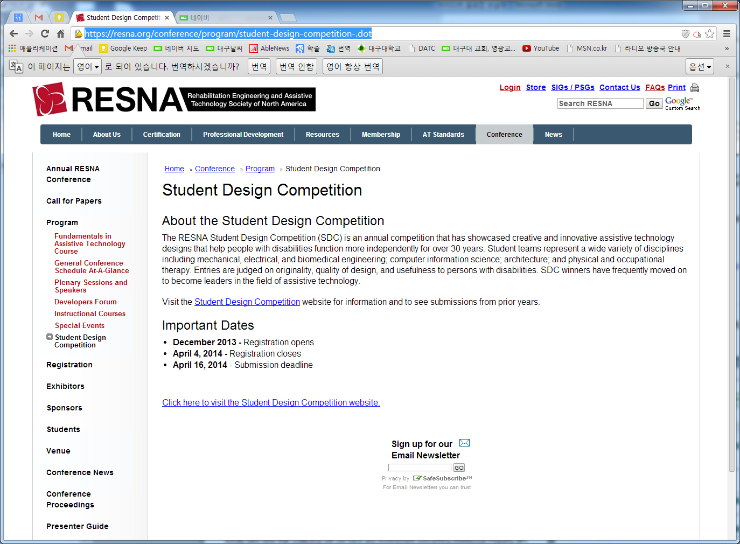

<https://resna.org/conference/program/student-design-competition-.dot>

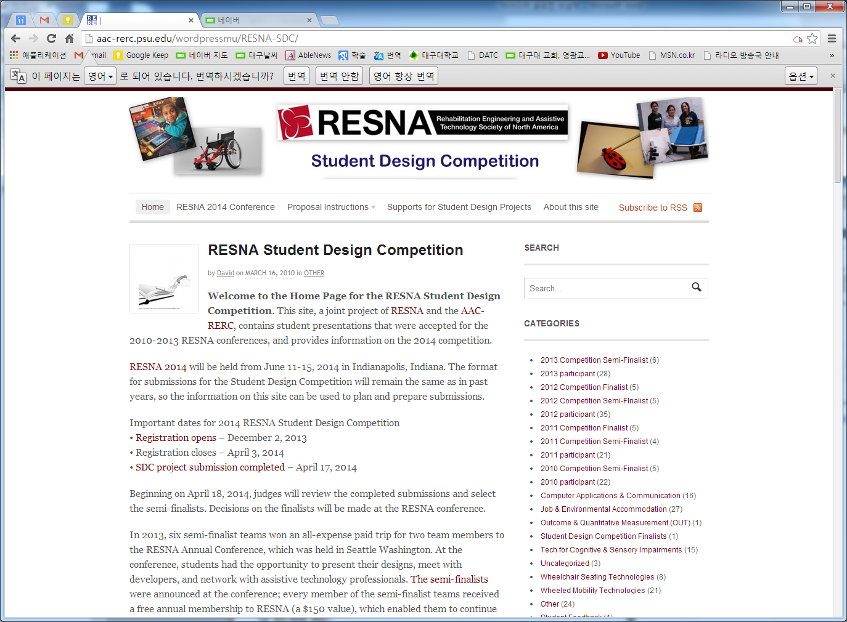

<http://aac-rerc.psu.edu/wordpressmu/RESNA-SDC/>

1. Abledata

<http://abledata.com/abledata.cfm?CFID=26160394&CFTOKEN=7583ad48c27db9c0-DEA52060-C4F8-24D1-D29E7C5C9F9B60CF>

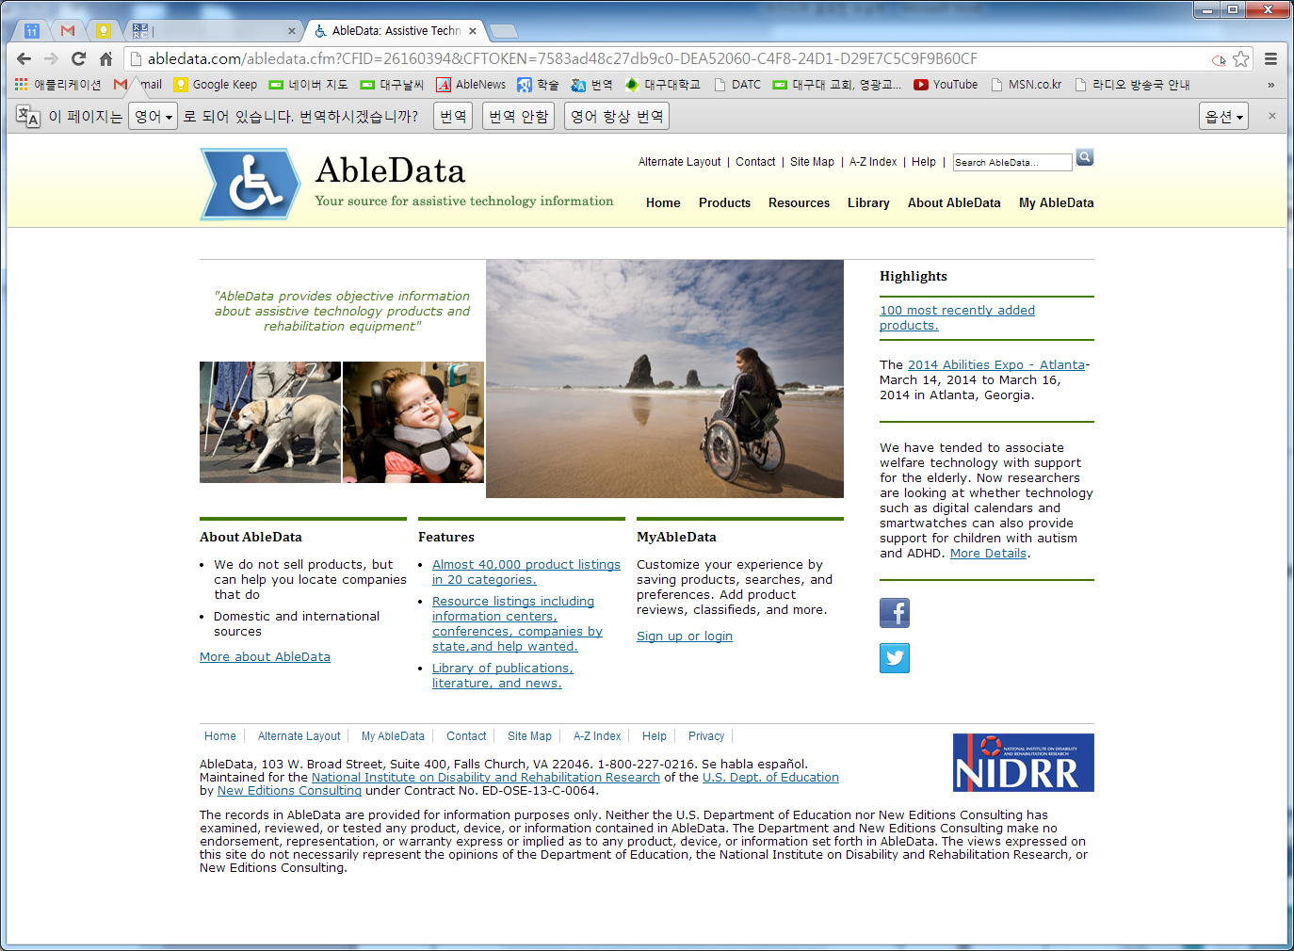

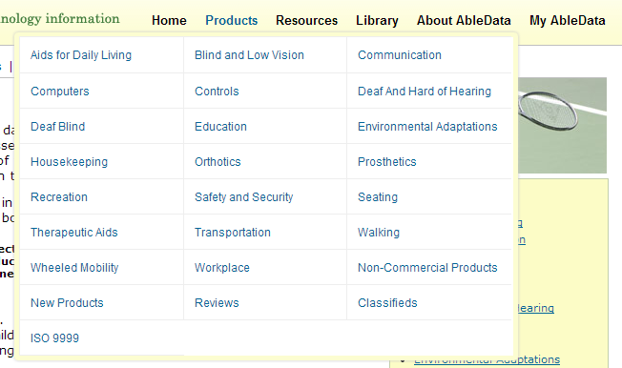

1. **장애인 보조기구 사례관리시범사업**

**-장애인 보조기구 품목 및 분류 체계**

<http://rtdb.nrc.go.kr/>

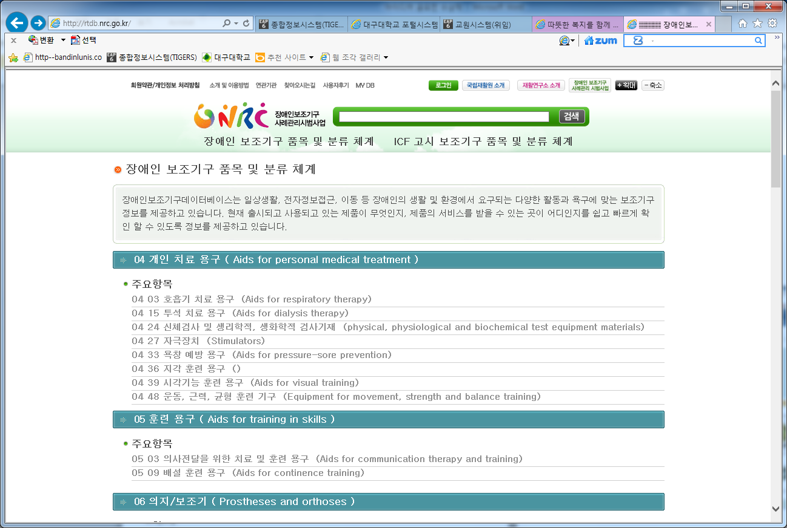

1. 경기도재활공학서비스연구지원센터

<http://www.atrac.or.kr/sub02/sub01.html>

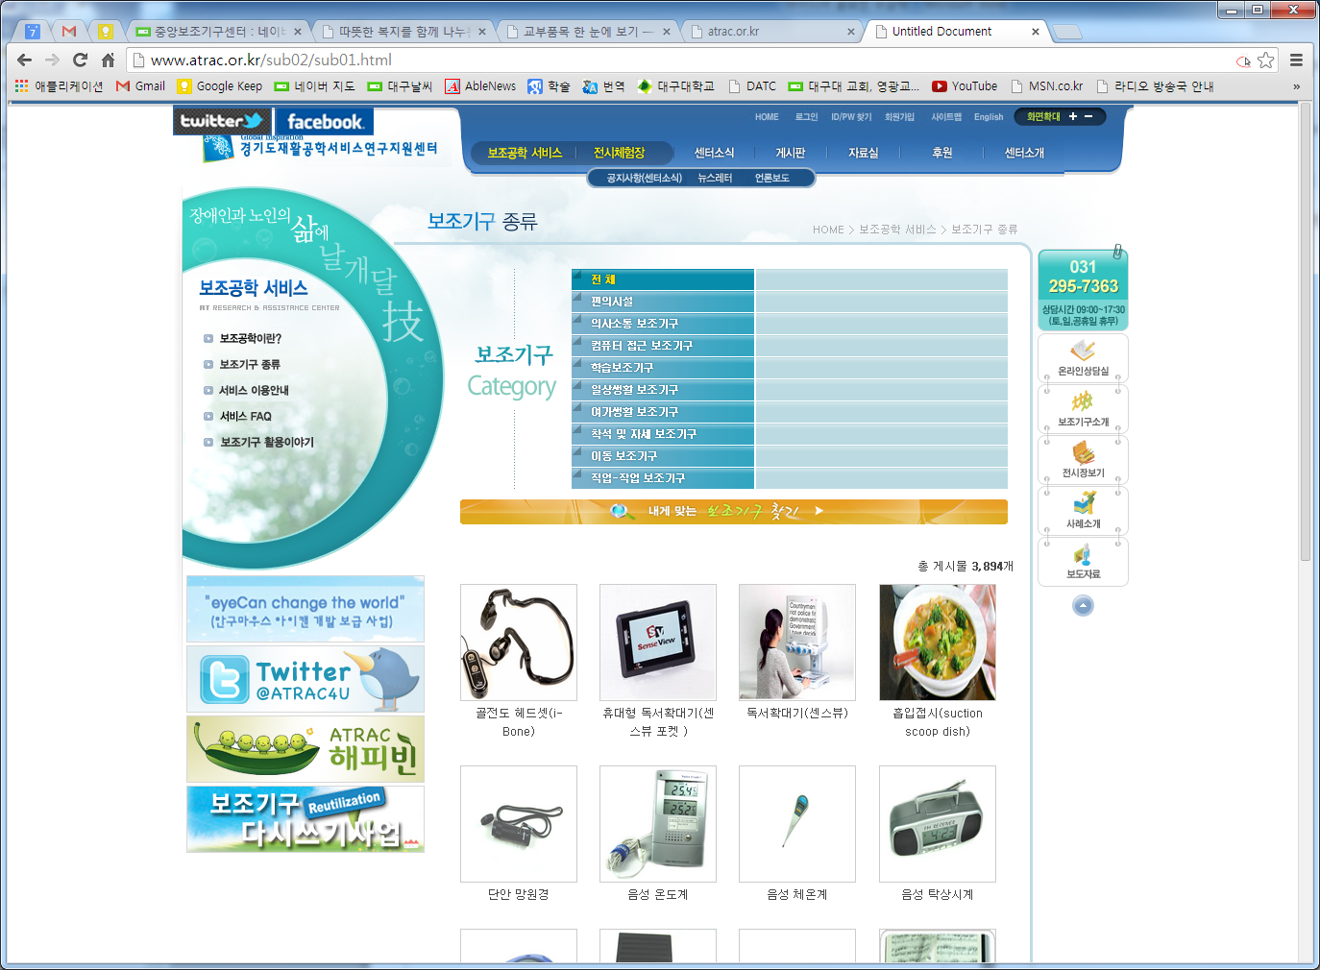

1. 에이블몰

<http://www.ablemall.co.kr/>

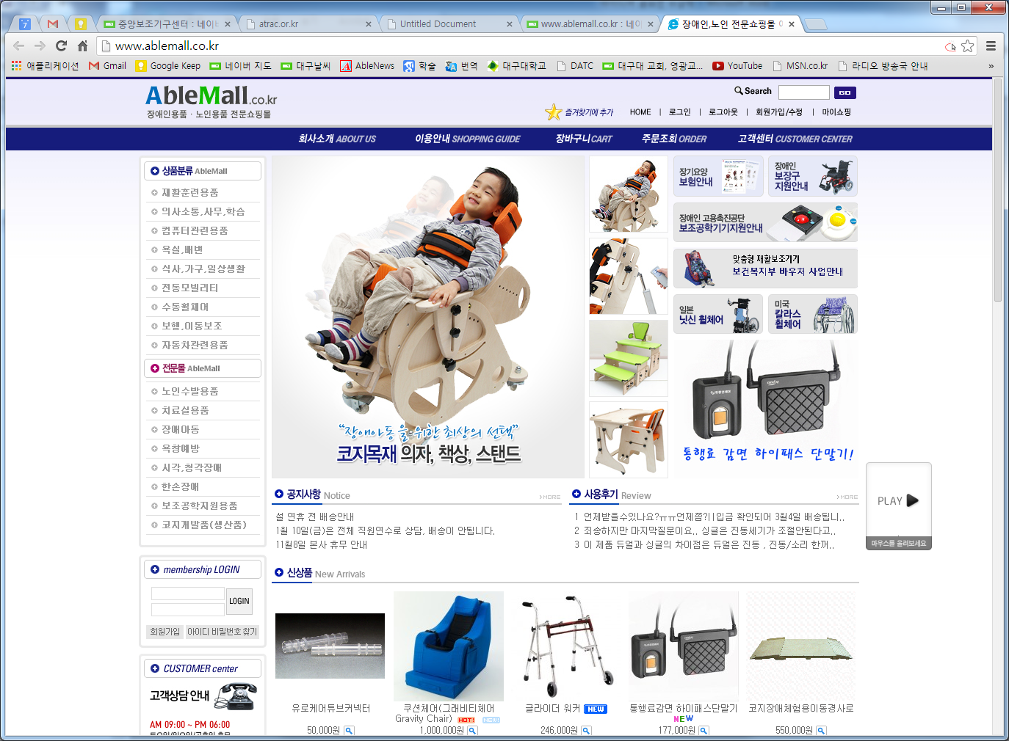

*** <http://rst.daegu.ac.kr/>